**HIV Pre-Exposure Prophylaxis (PrEP) guide for healthcare professionals working in a Primary Care.**

This document is to guide and support healthcare professionals working in South East London (SEL) to discuss HIV Pre-Exposure Prophylaxis (PrEP) with people who would potentially benefit from PrEP and to signpost them to sexual health clinics.

PrEP is taken before and after condomless sex to prevent the transmission of HIV. When taken correctly, PrEP is more than 99% effective however, it does not protect against other STIs. Anybody can take PrEP and their HIV risk and eligibility is assessed in sexual health clinics. This assessment and PrEP tablets are FREE of charge in the UK.

The following antiretroviral medicines can be used for PrEP:

* **Tenofovir disoproxil 245mg/emtricitabine 200mg** **fixed dose combination tablet or**
* **Descovy® (tenofovir alafenamide 25mg/emtricitabine 200mg) fixed dose combination tablet**

Descovy® is a newer version of standard PrEP (tenofovir disoproxil and emtricitabine) which is less likely to affect the kidneys or bones. It is recommended for people with or at risk of poor kidney or bone health. For example, for people under the age of 18 or for people with established renal disease or those who experience deterioration of renal function on standard PrEP (tenofovir disoproxil and emtricitabine).

You can either take PrEP:

**Daily**

All people can start PrEP by taking a double dose (at least 2 hours before sex) and then continue taking one tablet daily thereafter. When stopping PrEP, it should be continued for 2 days after the last risk for those having insertive sex or receptive anal sex and for 7 days after the last risk for those having receptive vaginal or neovaginal sex and those where the risk of HIV acquisition is through injecting drugs.

**Or On-demand/ event-based dosing (EBD)**

* + This involves taking PrEP around the time of sex. Dosing schedule will be discussed at the Sexual Health Clinic, but event-based dosing involves taking a double dose 2-24 hours before sex followed by a daily dose for either 2 or 7 days, depending on the type of sex as detailed above.

**Who is PrEP for?**

Anyone who is at risk of HIV acquisition could benefit from PrEP.

PrEP is especially important for the following people (however this list is not exhaustive):

* Gay, bisexual and other men who have sex with men (GBMSM)
* Partners of people who living with HIV positive and not on treatment/don't reliably take treatment who have a detectable HIV viral load.
* Sexually active heterosexual black African people who do not know the HIV status of their partner
* Any person who travels to, and has sex in, countries where there is a high prevalence of HIV
* Other indications may include: previous post-exposure prophylaxis (PEP) use, recent bacterial STI, people who engage in chemsex, injecting drug users or transgender individuals

**When should you discuss or consider PrEP?**

* If someone asks for it
* During contraception or emergency contraception appointments
* Patient diagnosed with STI or asking for an STI screen
* Any person in a new relationship
* Travel clinic appointment

*“Did you know that there is now medication that can protect you from HIV?”*

*“As well as having a full STI screen/contraception review/smear I think it would be sensible to discuss a new medication that you can take to protect you from HIV, are you already taking this or is it something that you have heard of?”*

*“Are there any other medications that you are getting or buying from any other services or hospital?”*

**What are the common side effects oral PrEP?**

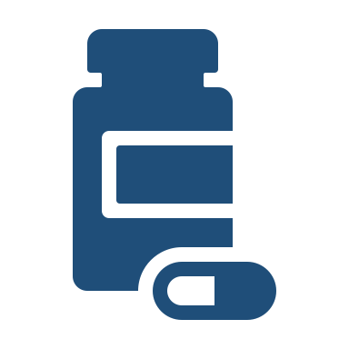**Short term** side effects are generally GI related including nausea, vomiting, diarrhoea, feeling bloated or flatulence but also headaches, dizziness or difficulty sleeping. Most are minor and will settle within a few days or weeks.

**Long term** side effects include renal impairment and bone damage as either osteopenia or osteoporosis. This is associated with tenofovir disoproxil based PrEP.

**What monitoring is done with PrEP?**



Complete 3 monthly **sexual health screening** including a HIV test – this can also be done via online home testing postal kits such as Sexual Health London ([Sexual Health London • SHL.UK](https://www.shl.uk/)).

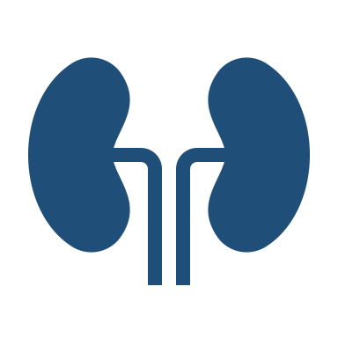**Renal function** is monitored by the sexual health clinic between 6 monthly and annually depending on age and renal risk factors.

Renal impairment may be caused by tenofovir disoproxil based PrEP. If eGFR < 90ml/min and they are on PrEP Repeat Renal function in 2-4 weeks. Rule out other causes such as protein/creatine supplements, DM, BP and check UACR.

If renal impairment likely due to PrEP please refer back to the sexual heath clinic as they may need a dose reduction or change to Descovy PrEP.



Consider **bone health**, if patient is under 18 or >50 with risk factors for osteoporosis, fracture risk should be calculated.

If someone on PrEP has new diagnosis, fragility fractures or QFracture/FRAX >10% then refer back to their sexual health clinic as appropriate as they may need to switch to Descovy PrEP.

**Useful resources:**

* BHIVA/BASHH guidelines on the use of HIV pre-exposure prophylaxis (PrEP) 2018: <https://www.bhiva.org/file/5b729cd592060/2018-PrEP-Guidelines.pdf>
* UK guide to PrEP – ibase: [PrEP-guide-UK-Feb-2024-FIN.pdf (i-base.info)](https://i-base.info/guides/wp-content/uploads/2024/02/PrEP-guide-UK-Feb-2024-FIN.pdf)
* <https://prepster.info/>
* <https://www.nhs.uk/medicines/pre-exposure-prophylaxis-prep/about-pre-exposure-prophylaxis-prep/>
* <https://www.shl.uk/prep>
* <https://peoplefirstcharter.org/>

**Sexual health clinics in SEL offering PrEP**

|  |  |  |  |
| --- | --- | --- | --- |
| **Guy’s and St Thomas’ Hospital Sexual Health services** | | | |
| **Clinic name** | Burrell Street Clinic | **Location** | 4-5 Burrell street, London, SE1 0UN |
| **How to access PrEP** | Book online: [book a PrEP appointment online using MyChart](https://mychart.gstt.nhs.uk/GSTT/openscheduling/standalone?dept=10212001&vt=943) or walk in.  Most appointments are available to book more than 48 hours in advance. In addition, on most weekdays and weekends, there will be some additional appointments released at 8:30am for later that same day as a walk in. | | |
| **Clinic name** | Walworth Road | **Location** | 159-167, Walworth Rd, London SE17 1RY |
| **How to access PrEP** | Walk in ONLY. | | |
| **Clinic name** | Minnie Kidd House | **Location** | 51C Hazelbourne Road, Clapham South, London SW12 9NU |
| **How to access PrEP** | Walk in ONLY. | | |
| **Website** | <https://www.guysandstthomas.nhs.uk/our-services/sexual-health/clinics> | | |
| **Kings College Hospital Sexual Health services** | | | |
| **Clinic name** | Camberwell Sexual Health Clinic | **Location** | 94-104 Denmark Hill, Camberwell  London, SE5 8RX |
| **How to access PrEP** | Walk in ONLY. | | |
| **Website** | <https://www.kch.nhs.uk/services/services-a-to-z/camberwell-sexual-health-centre/> | | |
| **Clinic name** | CliniQ clinic | **Location** | The Caldecot CentreKings College Hospital, 15 to 22 Caldecot Road, London, SE5 9RS |
| **How to access PrEP** | CliniQ is for Trans, non-binary and gender diverse people and only runs weekly on a Tuesday 4-6.30 pm, to book an appointment people can email [admin@cliniq.org.uk](mailto:admin@cliniq.org.uk) | | |
| **Website** | [https://cliniq.org.uk/pep-prep/](https://scanmail.trustwave.com/?c=8248&d=uqDq54VUNPc5wjQSj2TkfhwJXgN0tBSN6wLa6qvhHg&u=https%3a%2f%2fcliniq%2eorg%2euk%2fpep-prep%2f) | | |
| **Lewisham and Greenwich Sexual Health services** | | | |
| **Clinic name** | Waldron Health Centre | **Location** | Clinic, Suite 8, 2nd Floor, Amersham Vale, London, SE14 6LD |
| **How to access PrEP** | For people new to starting PrEP - Walk in ONLY  For people continuing on PrEP can book a virtual appointment: <https://nhs.herohealth.net/locations/prep-telehealth-online> | | |
| **Clinic name** | Trafalgar Clinic (Queen Elizabeth Hospital) | **Location** | West Entrance, Queen Elizabeth Hospital, Woolwich SE18 4QH |
| **How to access PrEP** | Walk in ONLY. | | |
| **Website** | <https://www.lewishamandgreenwich.nhs.uk/sexual-health/> | | |
| **Bromley Sexual Health services** | | | |
| **Clinic name** | Beckenham Sexual Health Walk in Clinic | **Location** | 379 Croydon Rd, Beckenham BR3 3QL |
| **How to access PrEP** | Walk in ONLY. | | |
| **Website** | [Beckenham Beacon sexual health clinic :: Bromley Sexual Health (sexualhealthbromley.co.uk)](https://www.sexualhealthbromley.co.uk/clinics/beckenham-beacon-sexual-health-clinic) | | |